**Exp-5 Design an automatic night lamp**

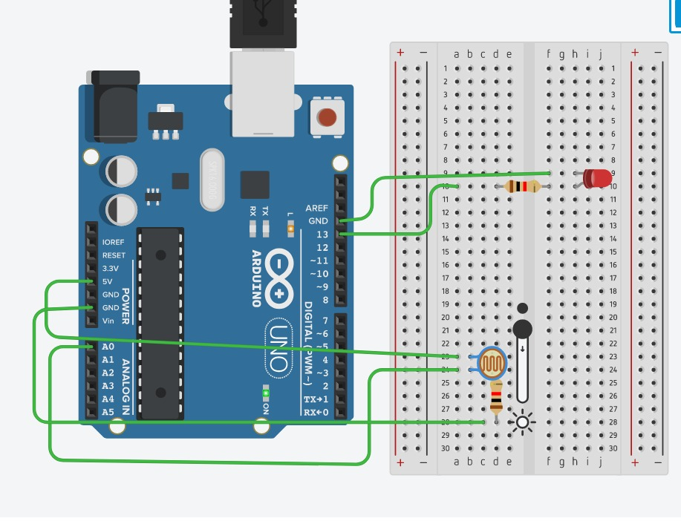

**Concept Used**

1.Light dependent resistors, LDRs or photo resistors are often used in circuits where it is necessary to detect the presence or the level of light.

They can be described by a variety of names from light dependent resistor, LDR, photo resistor, or even photo cell, photocell or photoconductor.

2.The Arduino board has ~ sign in Digital pin side which is also known as Pulse Width Modulation (PWM)**.**

These pins help in getting Analog signals with digital means.

3.When the intensity of the light rays fall on the LDR increases, the resistance of the LDR decreases and the LED does not glow.

**Learning and Observations**

1.Making a circuit using breadboard, Arduino and LDR.

2.2 digital pins are used where Digital pin 13 of the Arduino is in connection with the LED and other pin used is the Ground pin.

3.One terminal of LDR connected to the resistor of 10k ohm and the same terminal is also connected to the A0 pin and the other terminal is connected to the Ground.

4.The 10K ohm resistor is connected to the LDR and another terminal is connected to

the 5V supply.

5.Whenever it is day or enough light, the resistance of the LDR decreases. This in turn will not allow the LED to glow.

If there is darkness or light intensity is less than a particular value, the resistance of the LDR increases significantly. This will make the LED glow.

**Problems and Troubleshooting**

1.There was a slight confusion in understanding the transmission and receiving of data and then making the required connections.

2.Some minor errors were there, which were trouble shooted by the correcting the code.

**Precautions**

1.The connections must be correct.

2. All the equipment must be in working condition.

3.The connections made on the pins of the Arduino must coincide with the codes written on the software.

**Learning Outcomes: –**

1. Using the Arduino to set up various connections.

2. The concepts used in the LDR (Light Dependent Resistor).

3. Usage of LDR, LEDs and Arduino to design different circuits.

4. Improvise the learning of the Arduino.